CHAPTER 10: Heat and electricity
Worksheet 10.5

Ammeters and voltmeters
Science Quest 9: pages 361–4
Student: Class:

Constructing a circuit
1. The following circuit is incomplete as its components have not been connected to the electrical wires. Complete the circuit by drawing in the components in the correct positions. The voltmeter is measuring the potential drop across the light globe.
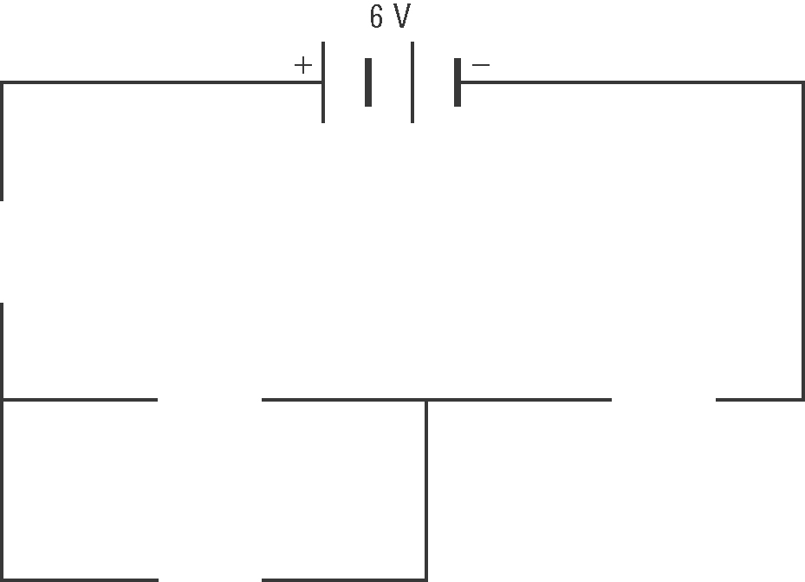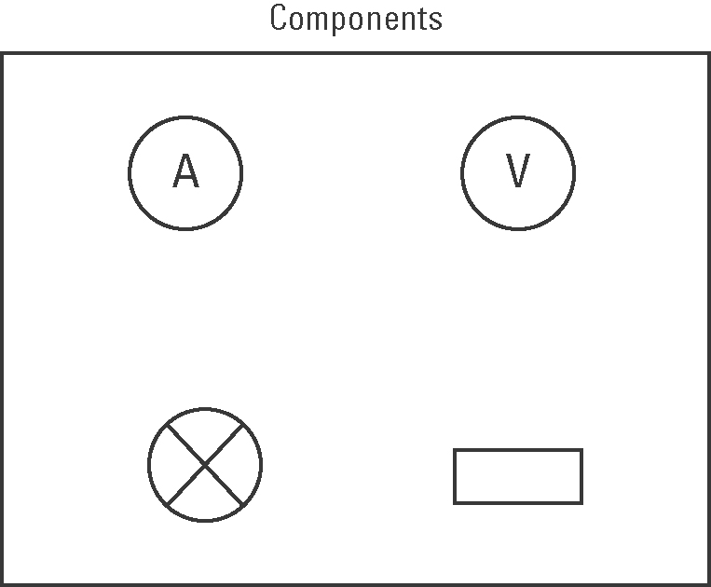

Lights in circuits
2. The following diagrams show two circuits with identical light globes and closed switches.
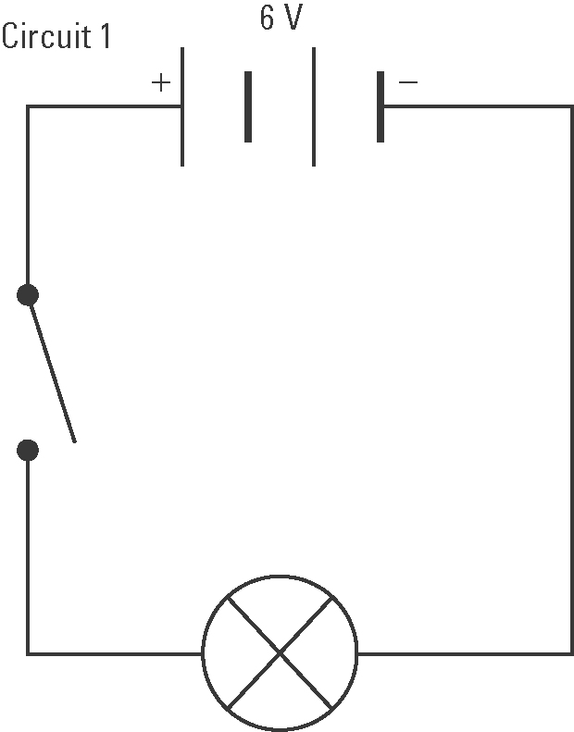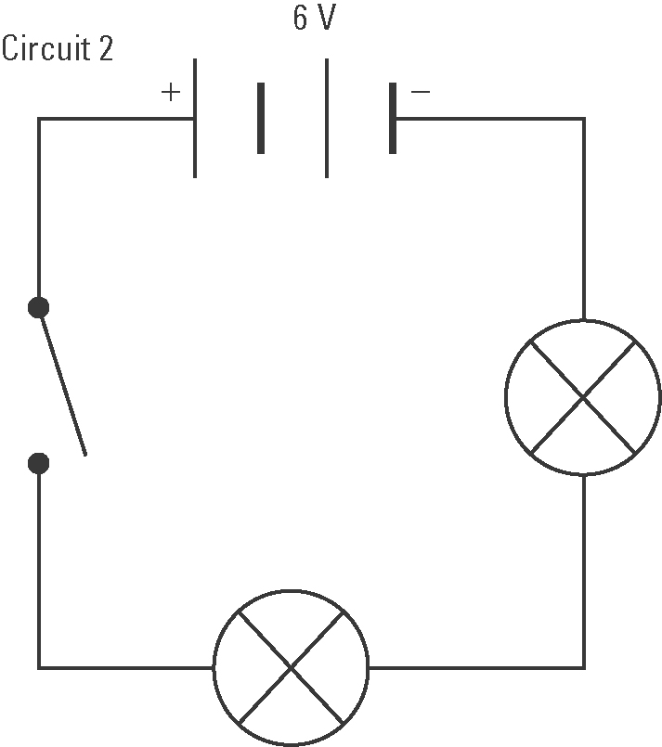
(a) In which circuit will the globe(s) glow brightest?

(b) Explain your answer to question (i).

(c) How many wires would you need to construct each circuit if a voltmeter were added?

